Marriott International Referral 2025 –
$1M Overall LM relationship
10 x 90 ABC for $52,500, replacing Everest
Loss History -

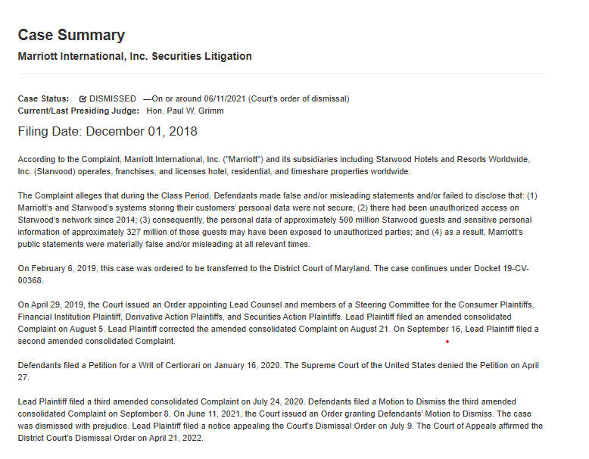
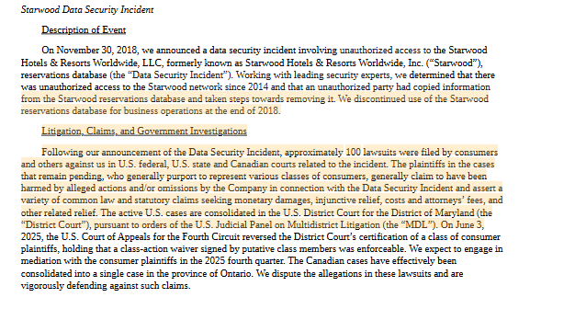
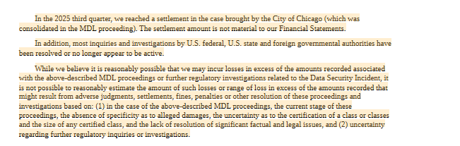

We currently write Marriott Vacations, there is no overlap with board composition.
Currently on a year extension – expiring below.
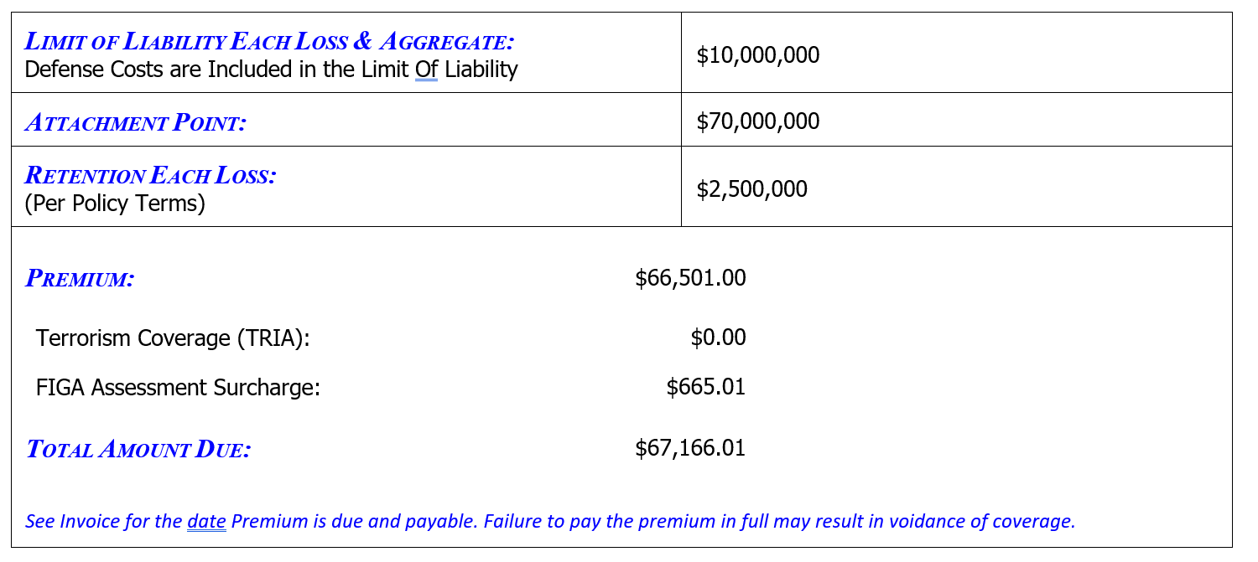
Marriott International STM -

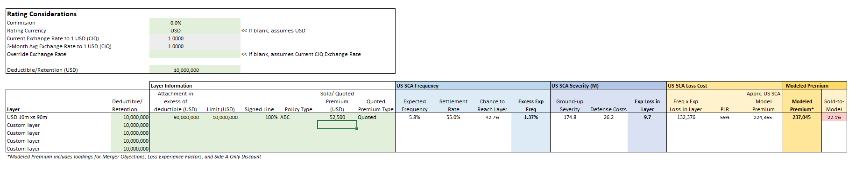
Marriott International, Inc. is a leading global operator, franchisor, and licensor of hotel, residential, timeshare, and other lodging properties. The company operates under more than 30 brand names, targeting a wide range of price and service points, and maintains an asset-light business model—owning or leasing less than one percent of its properties. As of year-end 2024, Marriott’s system comprised 9,361 properties with 1,706,331 rooms across 144 countries and territories, supported by a robust development pipeline of nearly 3,800 hotels. Marriott’s operations are organized into several reportable segments: U.S. & Canada, Europe, Middle East & Africa (EMEA), Greater China, and Asia Pacific excluding China (APEC), with the Caribbean & Latin America segment included in unallocated corporate and other. The company earns revenue primarily through management and franchise fees, and invests in technology systems to enhance customer experience, optimize revenue management, and support its loyalty program, Marriott Bonvoy. Marriott’s headquarters is located at 7750 Wisconsin Avenue, Bethesda, Maryland 20814. As of year-end 2024, Marriott managed the employment of approximately 418,000 associates worldwide, with 155,000 directly employed and 263,000 managed on behalf of hotel owners. This workforce size places Marriott at the 100th percentile among its industry peers. The company operates globally through a network of consolidated subsidiaries, including significant non-U.S. subsidiaries and Starwood Hotels & Resorts Worldwide, LLC. Marriott is consistently ranked as a top performer in the global lodging industry, recognized as the number one hotel brand in the U.S. & Canada, included in Fortune Magazine’s “World’s Most Admired Companies” for 2024, and listed among the top 10 companies on the Fortune 100 Best Companies to Work For®. Recent events and decisions include Marriott’s acquisition of the citizenM brand for $355 million, ongoing litigation and settlements related to the 2018 Starwood data breach, and management of financial guarantees totaling a maximum potential future funding of $203 million as of September 30, 2025. The company has noted some softening of demand in certain U.S. customer segments and is actively monitoring macroeconomic conditions. Marriott is also addressing climate and sustainability risks, anticipating significant future costs related to climate resiliency and compliance. Leadership changes in 2025 include the announced retirement of CFO Kathleen K. Oberg, with Jennifer C. Mason appointed as her successor, and ongoing board refreshment with seven of thirteen board nominees joining within the last five years. The current executive team is led by President and CEO Anthony G. Capuano, with David S. Marriott serving as Chairman of the Board.
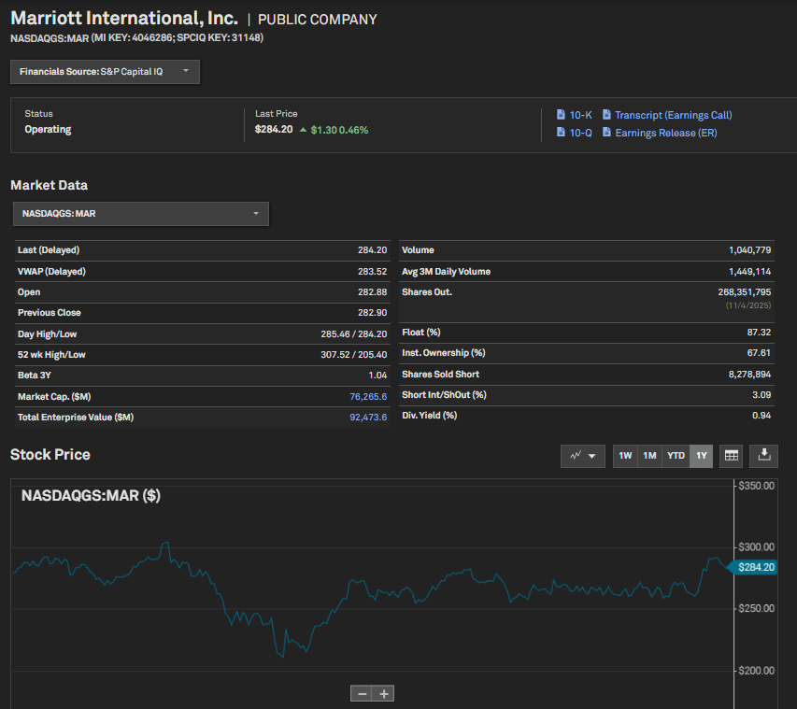
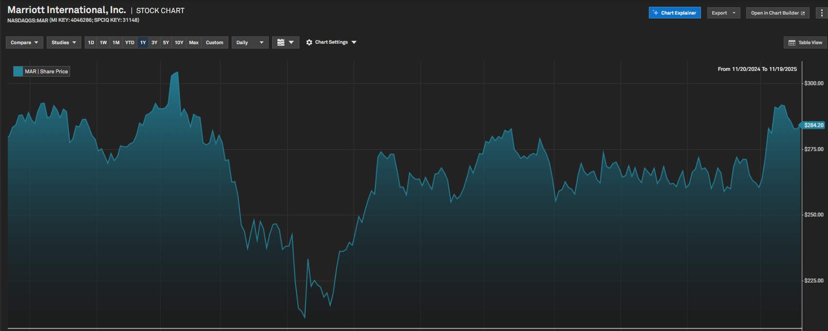
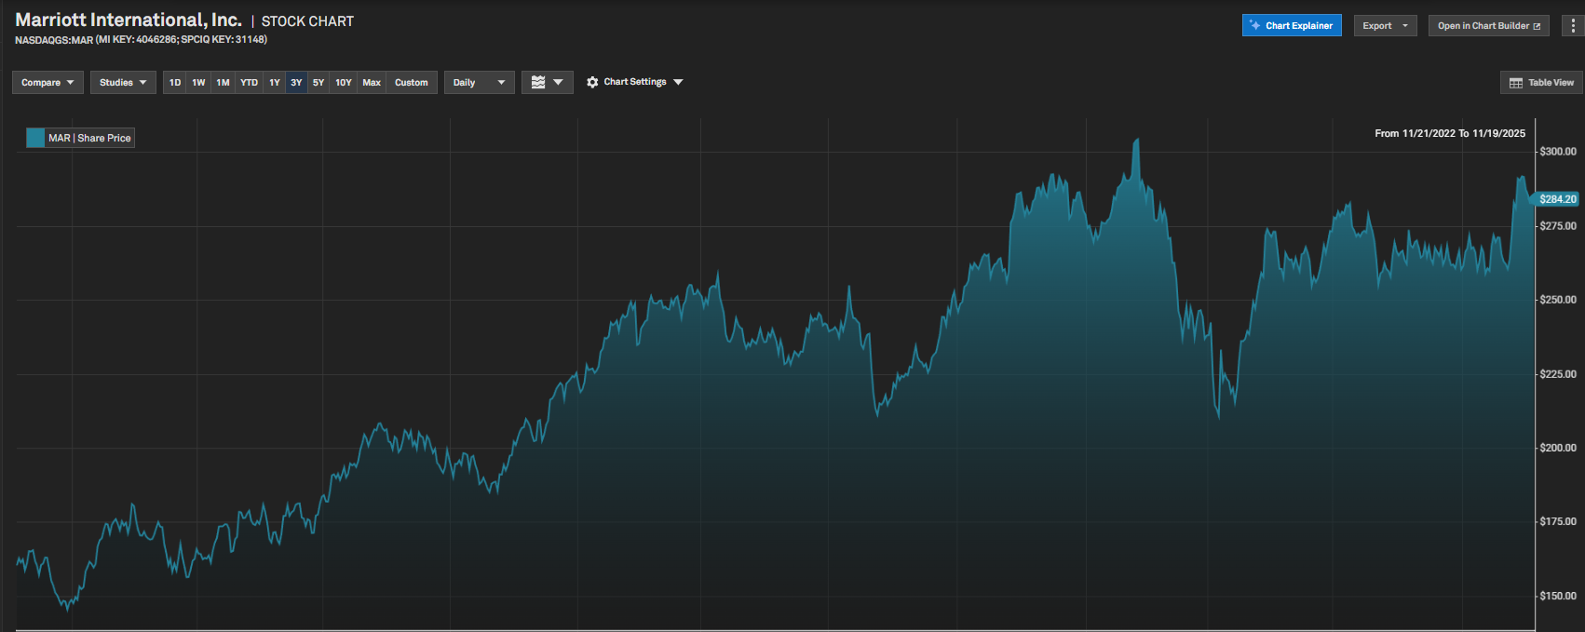
Key factors identified from these filings include:
- Softness in U.S. & Canada Operations: Marriott reported a decline in RevPAR (Revenue per Available Room) in its largest region, U.S. & Canada, with a 0.4% decrease in Q3 2025. This was attributed to weaker business transient and group demand, especially in select service hotels and government travel segments. (Quarterly Report, 2025-11-04, p.7)
- Greater China Weakness: RevPAR in Greater China was flat in Q3 and down 0.6% for the first three quarters of 2025, reflecting ongoing macroeconomic softness. (Quarterly Report, 2025-11-04, p.7)
- Rising Interest Expense: Interest expense increased by 15-17% in 2025 due to higher debt balances from new Senior Notes issuances. This is a direct result of substantial public debt offerings in February and August 2025, which raised approximately $3.4 billion in net proceeds. (Annual Report, 2025-02-11, p.41)
- Executive Changes: On July 14, 2025, Marriott announced the retirement of CFO Kathleen K. Oberg and the appointment of Jennifer C. Mason as her successor. Leadership transitions, especially at the CFO level, can create uncertainty and contribute to stock price volatility. (Current Report, 2025-07-14, p.1)
- Legal and Regulatory Issues: Marriott received a letter from the U.S. Environmental Protection Agency (EPA) regarding alleged Clean Air Act violations at a managed hotel, which could lead to enforcement actions or lawsuits. The company also continues to face litigation and regulatory settlements related to the 2018 Starwood data breach. (Annual Report, 2025-02-11, p.13)
- Shareholder Returns and Treasury Stock Purchases: Marriott has been actively repurchasing shares, with $3.76 billion spent on treasury stock in 2024 and $2.28 billion in the first three quarters of 2025. While buybacks can support the stock price, they may also signal management's view that organic growth opportunities are limited or that the stock is undervalued due to recent declines. (Annual Report, 2025-02-11, p.41; Quarterly Report, 2025-11-04, p.12)
- General Market Sentiment and Reputation Risks: The filings note that negative incidents, adverse media publicity, and government investigations can quickly erode trust and confidence, leading to tangible adverse effects on business and stock price. (Annual Report, 2025-02-11, p.13)
In summary, the recent drops in Marriott International's stock price are attributable to weaker performance in key markets (notably U.S. & Canada and Greater China), increased interest expenses from higher debt, executive transitions, ongoing legal and regulatory risks, and general market sentiment reacting to these factors. The numbers cited above are actual reported results and not hypothetical or projected figures.

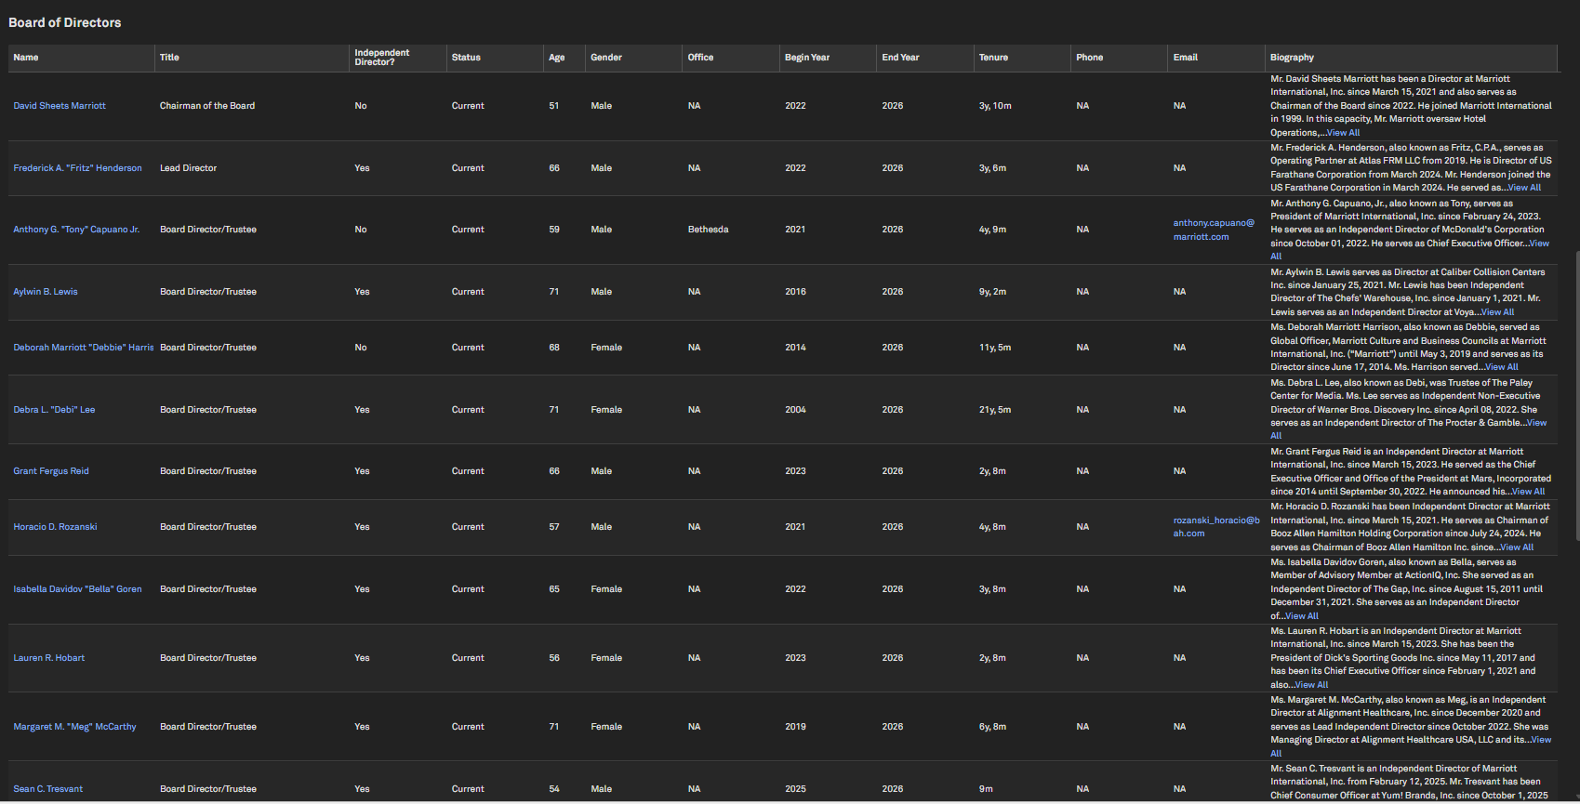
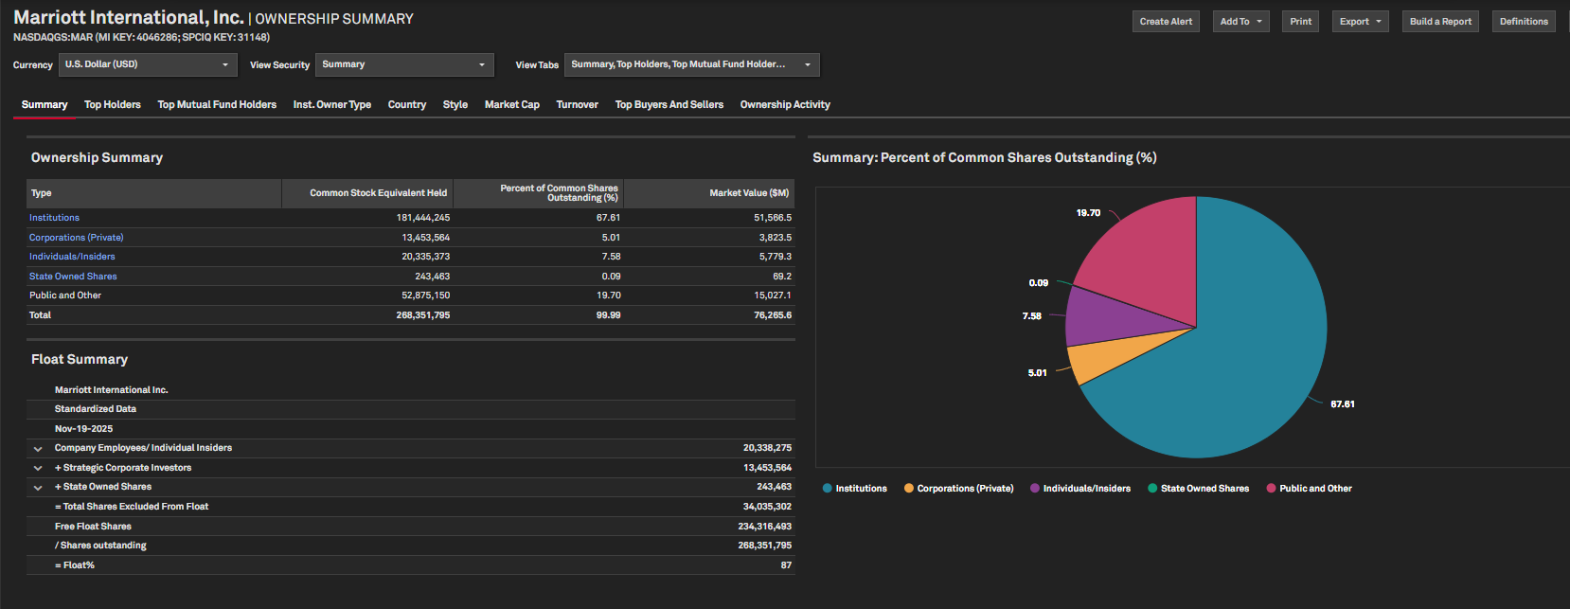
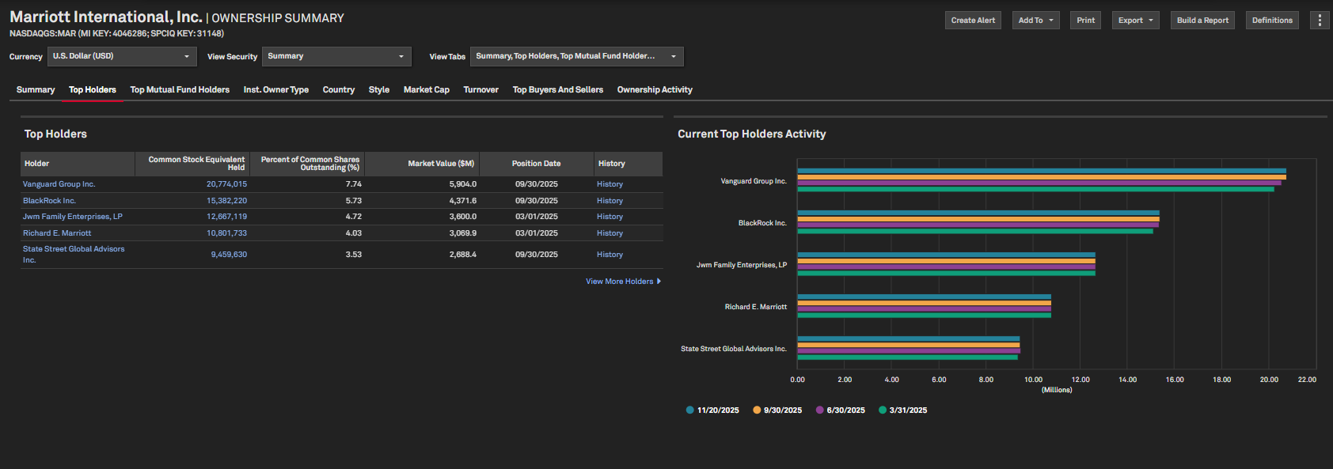
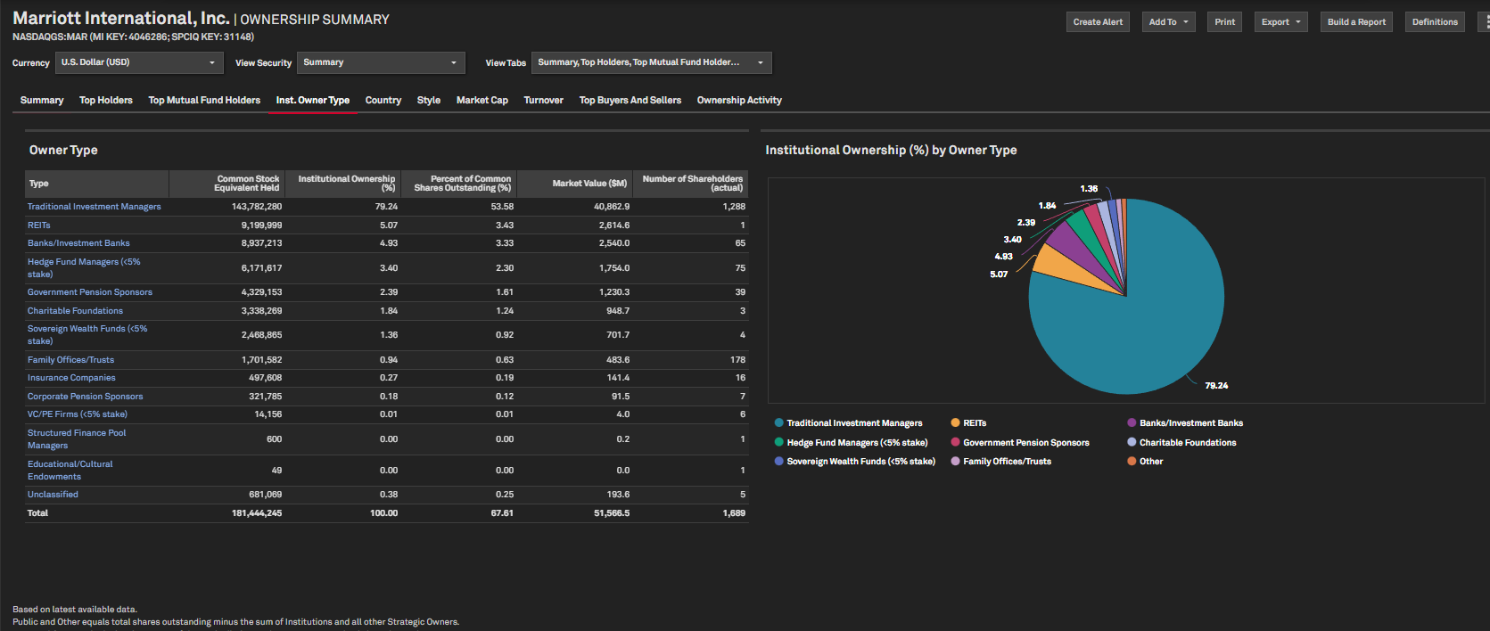
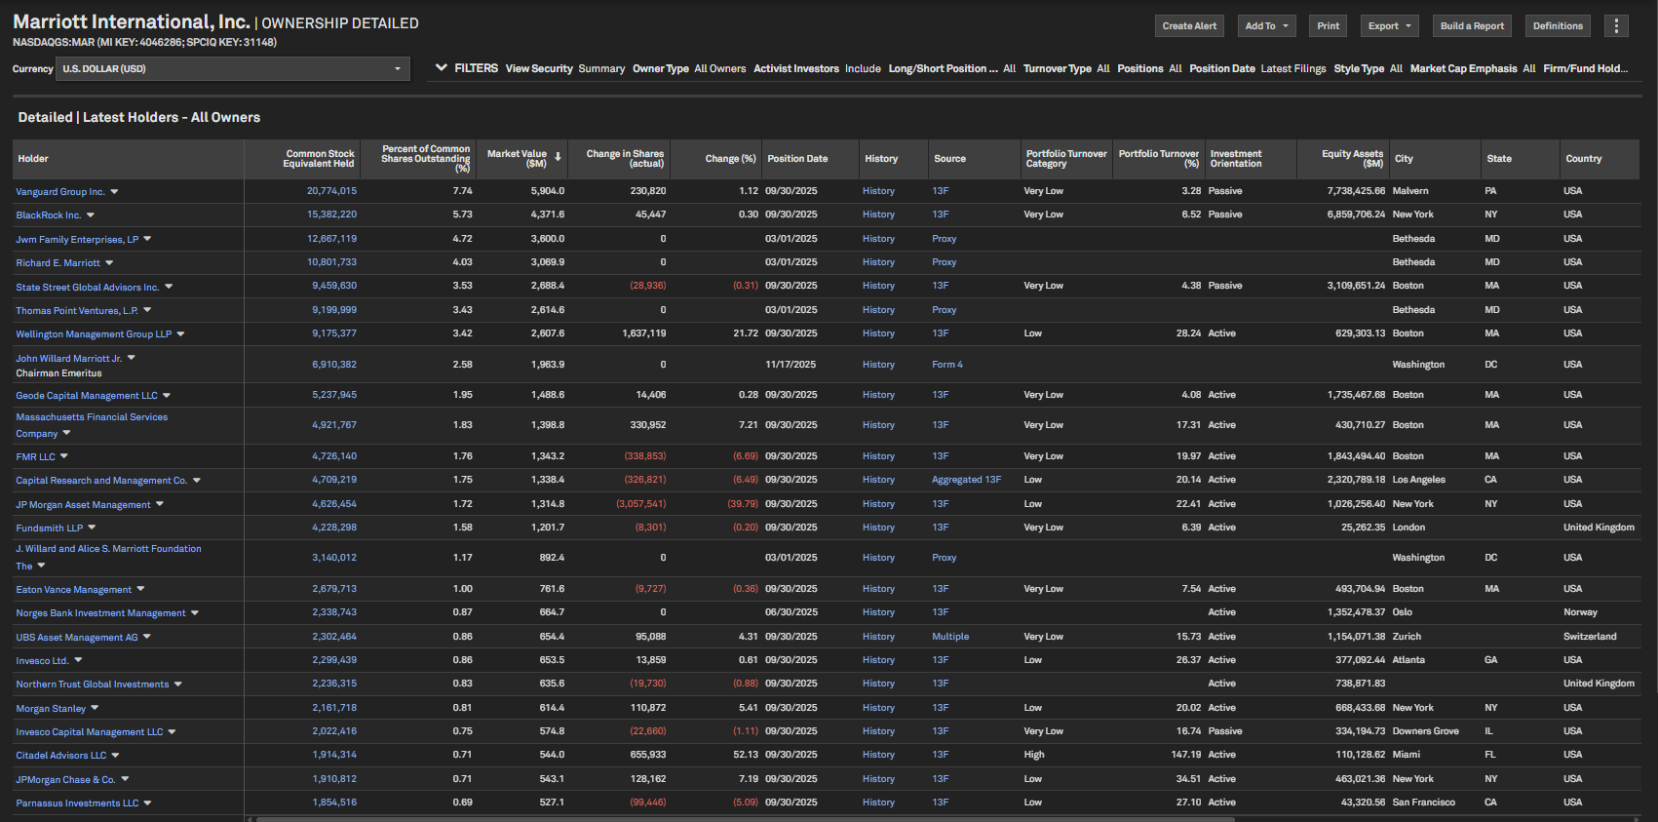
- There have been changes in chief officers and members of the board of directors within the last 12 months. Specifically: (1) On July 14, 2025, Marriott announced the appointment of Jennifer C. Mason as Executive Vice President and Chief Financial Officer, effective upon Kathleen K. Oberg stepping down from her role. Kathleen K. Oberg notified Marriott of her intent to retire and step down from her role immediately following the filing of the Annual Report for fiscal year 2025. (2) On January 17, 2025, the Board of Directors elected Sean Tresvant to the Board, effective February 12, 2025. These changes are within the most recent 12-month period and involve both an officer (CFO) and a board member.
- The company has conducted significant securities offerings in 2025. On February 26, 2025, it issued $500 million of Series RR Notes and $1.5 billion of Series SS Notes, with net proceeds of approximately $1.96 billion. On August 20, 2025, it issued additional Notes with net proceeds of approximately $1.477 billion. Both offerings were public debt issuances, and the amounts are substantial, indicating discrete rounds of investment to fund general corporate purposes. These offerings are important and clearly meet the threshold for a securities offering as defined in the question.
- The documents clearly state that there was a data security incident involving unauthorized access to the Starwood Hotels & Resorts Worldwide reservations database. The incident was announced on November 30, 2018, and it was determined that unauthorized access had occurred since 2014, with information copied from the database. The company discontinued use of the database at the end of 2018 and faced litigation as a result.
- The company has made restructuring of operations, as evidenced by the presence of 'Restructuring and merger-related (recoveries) charges' in the cash flow statement and a detailed restructuring reserve activity table showing employee termination benefits. However, there is no evidence of capital restructuring such as conversion of debt to equity. The restructuring activities described are operational, including employee termination benefits and related charges, but do not include examples like debt-to-equity conversion.
- The documents indicate that the company has been subject to legal proceedings within the last year. Specifically, in the 2025 second quarter, the company received a letter from the U.S. Environmental Protection Agency (EPA) regarding alleged violations of the Clean Air Act at a hotel it manages, which could lead to a lawsuit or enforcement action. Additionally, the company states that it is subject to other legal proceedings and claims in the ordinary course of business. While the ongoing lawsuits related to the Data Security Incident are older, the EPA matter and other legal proceedings are recent and fall within the last year.
- The documents indicate that the company has been subject to investigations and settlements with various governmental authorities, including U.S. federal, state, and foreign agencies, related to a Data Security Incident. Specifically, the company reached final resolutions with the Federal Trade Commission and the Attorney General offices from 49 states and the District of Columbia, which included a $52 million monetary payment. While the documents do not explicitly mention a 'securities commission' investigation or settlement, the involvement of the Federal Trade Commission and the Attorney General offices, as well as references to regulatory investigations, strongly suggest that securities-related authorities have investigated the company and settlements have occurred.

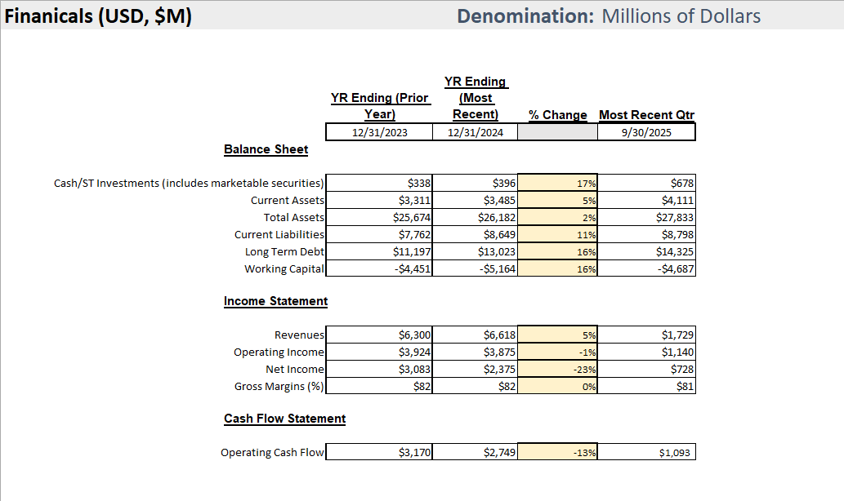
Financial Notes -
Income Statement Highlights (Nine Months Ended September 30, 2025)
- Total revenues: $19.50 billion (up from $18.67 billion for the same period in 2024)
- Net fee revenues: $3.93 billion (up from $3.76 billion)
- Owned, leased, and other revenue: $1.22 billion (up from $1.13 billion)
- Cost reimbursement revenue: $14.35 billion (up from $13.78 billion)
- Operating income: $3.36 billion (up from $3.02 billion)
- Net income: $2.16 billion (up from $1.92 billion)
- Diluted earnings per share: $7.84 (up from $6.69)
Balance Sheet Highlights (as of September 30, 2025)
- Total assets: $27.83 billion (up from $26.18 billion at year-end 2024)
- Cash and equivalents: $678 million (up from $396 million)
- Accounts and notes receivable, net: $3.10 billion
- Goodwill: $8.89 billion
- Intangible assets (brands, contracts, etc.): $10.20 billion
- Current portion of long-term debt: $1.56 billion
- Long-term debt: $14.44 billion (up from $13.14 billion)
- Liability for guest loyalty program: $7.82 billion (current + long-term)
- Stockholders’ deficit: $(3.12) billion (driven by large treasury stock repurchases and accumulated other comprehensive loss)
Cash Flow Highlights (Nine Months Ended September 30, 2025)
- Net cash provided by operating activities: $2.38 billion
- Net cash used in investing activities: $(775) million
  - Capital and technology expenditures: $(432) million
  - Asset acquisition (citizenM brand): $(349) million
- Net cash used in financing activities: $(1.34) billion
  - Issuance of long-term debt: $3.44 billion
  - Repayment of long-term debt: $(957) million
  - Dividends paid: $(539) million
  - Purchase of treasury stock: $(2.30) billion
Key Trends and Observations
- Revenue and net income continue to grow year-over-year, driven by international expansion and fee-based income.
- Debt levels have increased due to new note issuances, but liquidity remains strong.
- Significant capital returned to shareholders via share repurchases and dividends.
- Negative equity position persists, primarily due to aggressive share buybacks, not operational weakness.
- Cash and equivalents have increased, and the company maintains access to substantial credit facilities.
Recent Notable Events
- Acquisition of the citizenM brand for $355 million (Q2 2025).
- Continued investment in technology and global systems.
- Ongoing restructuring and merger-related activities, but no capital restructuring (e.g., debt-to-equity conversion).
Summary: Marriott International demonstrates solid financial performance with growing revenues, strong cash flow, and continued investment in growth and technology. The company is highly leveraged but maintains ample liquidity and continues to return capital to shareholders. The negative equity position is a result of large-scale share repurchases rather than operational weakness.

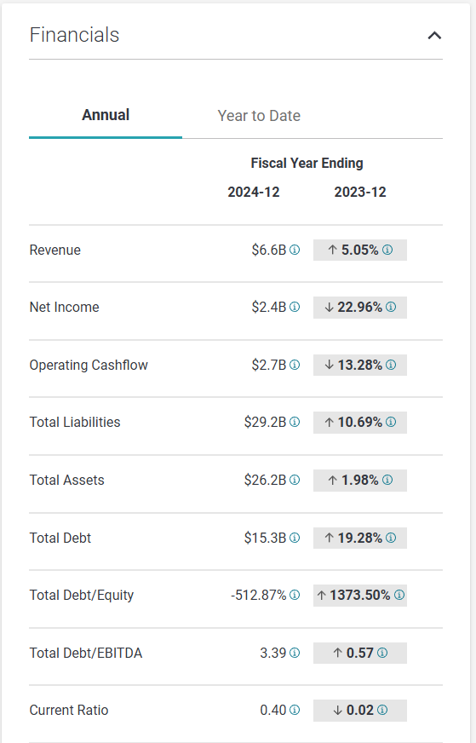
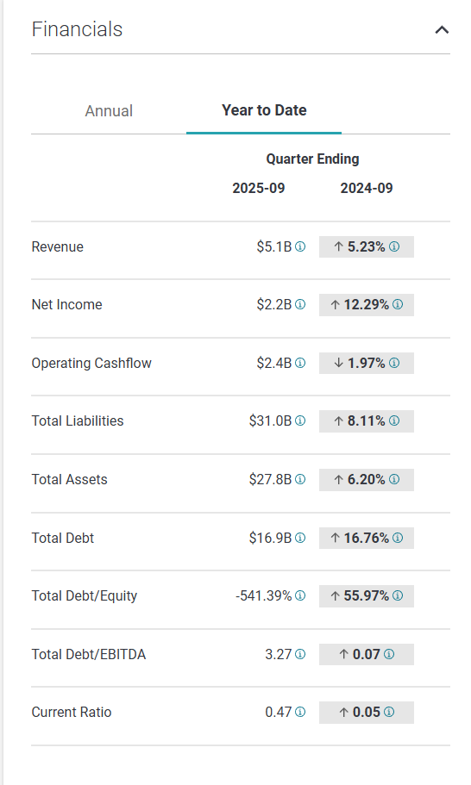

Financial Overview –
- Marriott’s interest expense increased by $86 million (17%) in the first three quarters of 2025 compared to the same period in 2024, primarily due to higher debt balances from new Senior Notes issuances (see Q3 2025 Quarterly Report, p. 21). For example, interest expense for the nine months ended September 30, 2025 was $601 million, up from $515 million in 2024.
- The company manages these increased costs through several specific actions:
  - Maintaining a strong liquidity position: As of June 30, 2025, Marriott had $15.7 billion in total debt and access to a $4.5 billion credit facility, with cash and equivalents increasing by $269 million since year-end 2024 (Q2 2025 Quarterly Report, p. 9).
  - Actively managing debt maturities and refinancing: Marriott issued $1.96 billion in new notes in February 2025 and $1.477 billion in August 2025, while also retiring or maturing older debt (Q2 2025 Quarterly Report, p. 9; Annual Report, p. 28). The company’s weighted average interest rate on long-term debt was 4.5% at year-end 2024, with a weighted average maturity of approximately 5 years (Annual Report, p. 28).
  - Cost discipline: General, administrative, and other expenses decreased by $32 million in the first three quarters of 2025, helping offset higher interest costs (Q3 2025 Quarterly Report, p. 21).
  - Asset-light model and capital recycling: Marriott continues to minimize capital invested in owned assets, favoring management/franchise agreements and asset sales to generate cash for debt service (Annual Report, p. 28).
- The company paid $328 million in cash for interest in the first half of 2025, compared to $303 million in the first half of 2024 (Q2 2025 Quarterly Report, p. 9), reflecting the impact of new debt but also demonstrating its ability to meet obligations from operating cash flows.
In summary, Marriott is managing increased interest expenses by maintaining robust liquidity, optimizing its debt portfolio, reducing operating costs, and leveraging its asset-light business model to generate stable cash flows for debt service. These strategies are explicitly detailed in the company’s filings and reflect a proactive approach to debt and interest expense management.

Positive Aspects
- Global Growth and Expansion: The company continues to expand its global footprint, with the total number of properties and rooms increasing by 7% and 5% year-over-year, respectively. The development pipeline remains robust, with over 3,900 properties and 596,000 rooms, and more than half of new rooms located outside the U.S. & Canada.
- Revenue and Fee Growth: Net fee revenues increased by 4% for both the third quarter and the first three quarters of 2025, driven by higher RevPAR, rooms growth, and increased franchise and co-branded credit card fees.
- International Performance: International regions (EMEA, APEC, CALA) showed strong RevPAR and ADR growth, with particularly notable gains in the Middle East & Africa and Asia Pacific excluding China.
- Strong Liquidity Position: The company maintains significant liquidity through a $4.5 billion credit facility, healthy cash balances, and access to capital markets. Cash and equivalents increased by $269 million since year-end 2024.
- Shareholder Returns: The company continues to return value to shareholders through share repurchases ($2.6 billion YTD) and regular dividend payments, with increases in dividend per share during 2025.
- Cost Management: General, administrative, and other expenses decreased, primarily due to lower compensation costs and guarantee reserves.

Challenges
- U.S. & Canada Softness: RevPAR in the U.S. & Canada declined 0.4% in Q3 2025, with weaker business transient and group demand, especially in select service hotels and government travel segments.
- Greater China Weakness: RevPAR in Greater China was flat in Q3 and down 0.6% for the first three quarters, reflecting ongoing macroeconomic softness.
- Increased Interest Expense: Interest expense rose by 15-17% due to higher debt balances from new Senior Notes issuances.
- Data Security Incident: The company continues to face uncertainty regarding the total financial impact of the 2018 Starwood data security incident, though it does not expect long-term financial harm.
- Tax Rate Impact: Income tax provisions increased due to higher pre-tax income and a shift in earnings to higher-tax jurisdictions.
- Asset-Light Model Limitations: While the asset-light model reduces capital risk, it may limit upside from property appreciation and direct operational control.

Strategic Considerations
- Asset-Light Model: The focus on management, franchising, and licensing (rather than ownership) supports scalability and reduces capital intensity, but requires strong brand and operational oversight.
- International Diversification: Continued emphasis on international growth, especially in EMEA and APEC, helps offset regional weaknesses and diversifies revenue streams.
- Pipeline Execution: The large development pipeline, including the integration of the citizenM brand, is critical for sustaining future growth and market share.
- Technology Investments: Elevated capital and technology expenditures, particularly for global systems transformation, are expected to be largely reimbursed but require careful execution to avoid disruption.
- Shareholder Capital Returns: Ongoing share repurchases and dividends signal confidence in cash flow generation, but must be balanced against investment needs and debt management.
- Risk Management: Ongoing legal, regulatory, and cybersecurity risks (e.g., data breaches) require vigilant oversight and investment in compliance and security infrastructure.

Sentiment Conclusion
Overall, the document reflects a cautiously optimistic outlook. The company demonstrates solid global growth, effective cost management, and a strong liquidity position, supporting continued shareholder returns. However, regional demand softness (notably in the U.S. & Canada and Greater China), rising interest expenses, and unresolved legacy risks (such as the data security incident) temper the positive momentum. The sentiment is constructive, with management focused on leveraging its asset-light model, international expansion, and technology investments to drive future performance, while remaining mindful of evolving risks and market uncertainties.

